USER 1--->NUMBER OF PACKETS VS TIME(SECONDS)
USER 1 TALKING
RED--> SRC is 128.119.240.128 ; DEST is 173.194.207.127
BLUE--> SRC is 173.194.207.127.128 ; DEST is 128.119.240.128

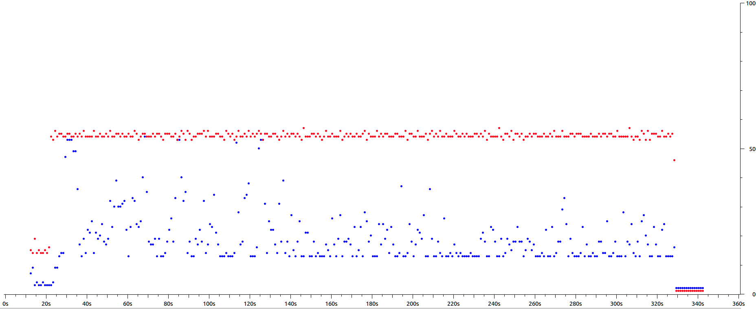

X AXIS--->TIME(SECONDS)
Y AXIS--->PACKETS

USER 2--->NUMBER OF PACKETS VS TIME(SECONDS)
USER 2 NOT TALKING; NOT ON MUTE
RED--> SRC is 10.3.40.145 ; DEST is 173.194.207.127
GREEN--> SRC is 173.194.207.127.128 ; DEST is 10.3.40.145
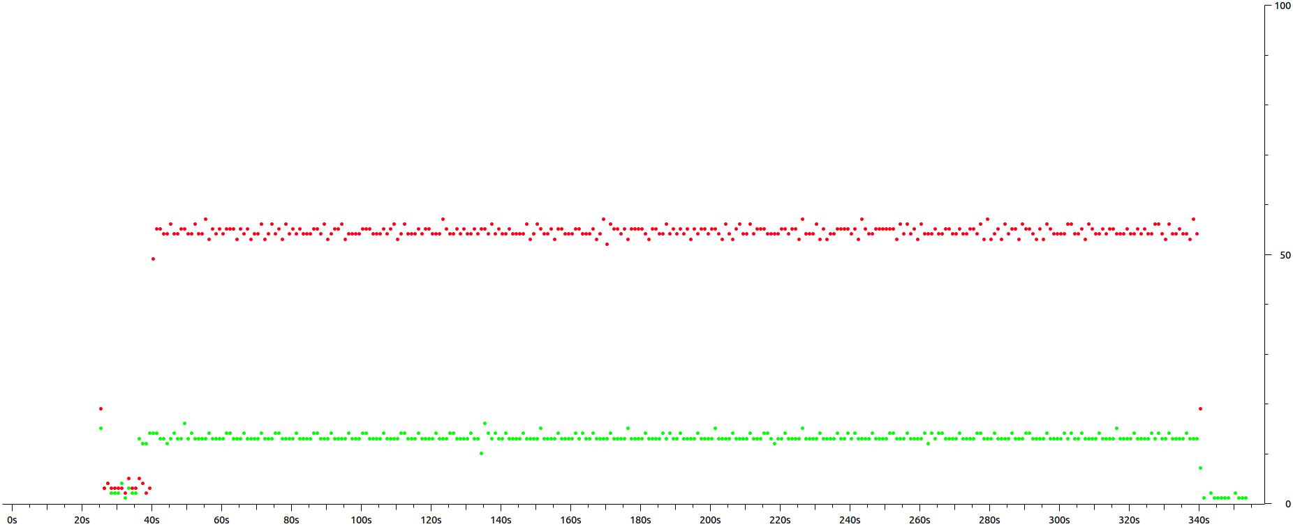

X AXIS--->TIME(SECONDS)
Y AXIS--->PACKETS

USER 1-->INTER-PACKET GAP
USER 1 TALKING
RED--> SRC is 128.119.240.128 ; DEST is 173.194.207.127
BLUE--> SRC is 173.194.207.127.128 ; DEST is 128.119.240.128
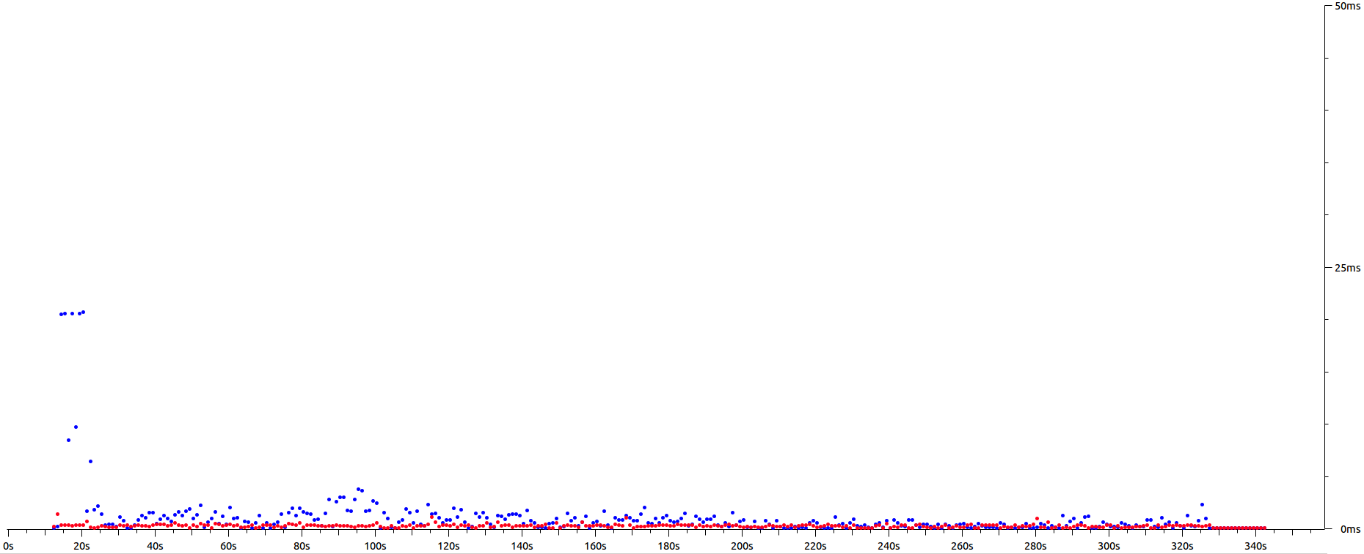

X AXIS--->TIME(SECONDS)
Y AXIS--->INTER-PACKET DELAY(MS)

USER 2--->INTER-PACKET GAP
USER 2 NOT TALKING; NOT ON MUTE
RED--> SRC is 10.3.40.145 ; DEST is 173.194.207.127
GREEN--> SRC is 173.194.207.127.128 ; DEST is 10.3.40.145

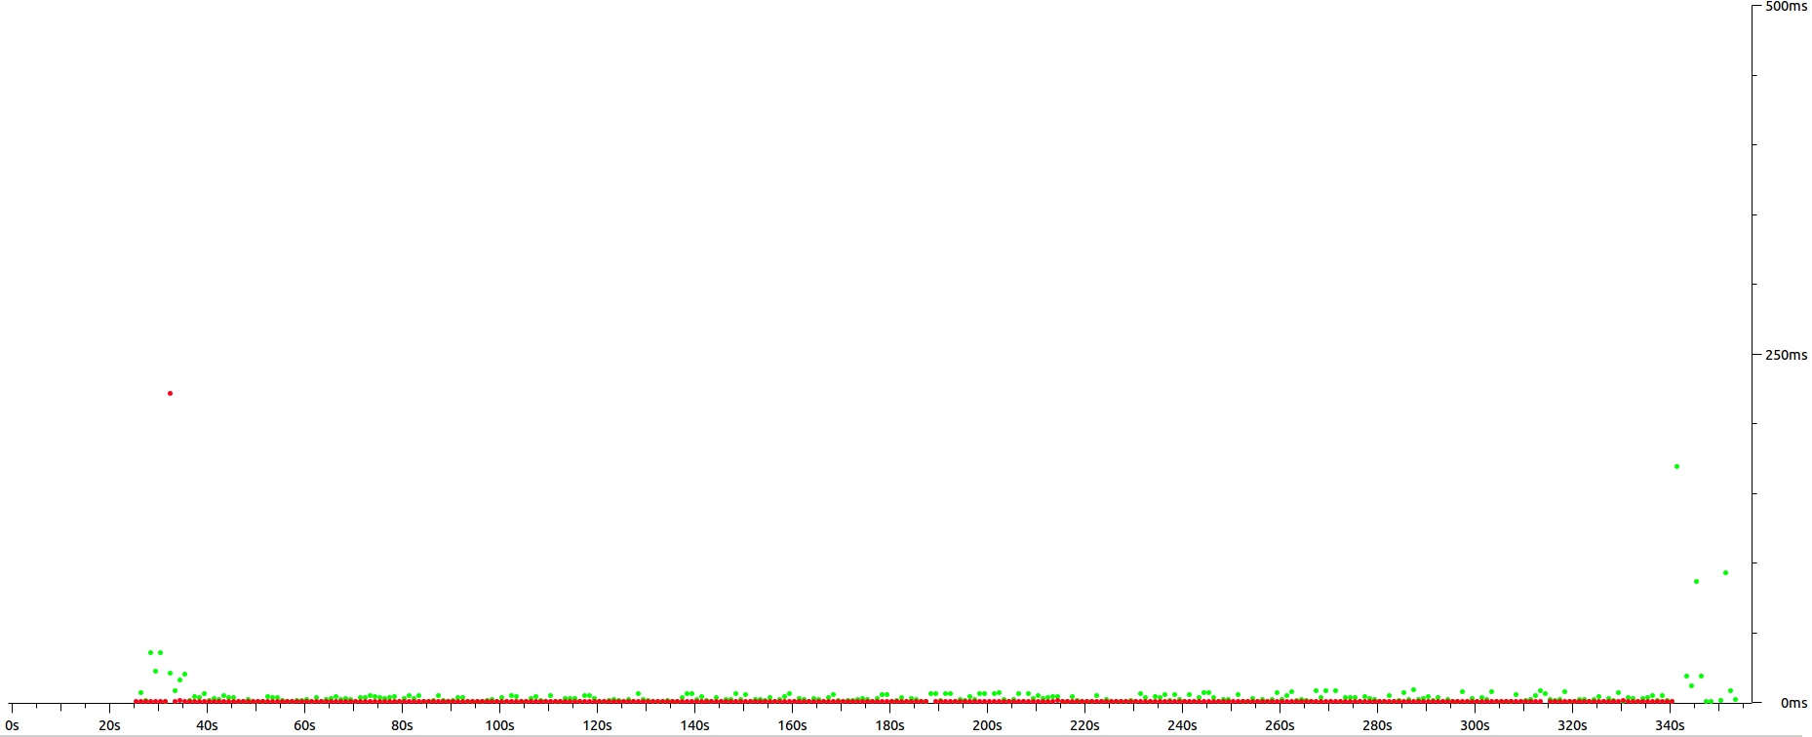

X AXIS--->TIME(SECONDS)
Y AXIS--->INTER-PACKET DELAY(MS)

